**Login & Register**

**Primary Actor:** The User (VT Student/Staff member)

**ER (Entity Relationship) Diagram for Login & Register Functionality:**

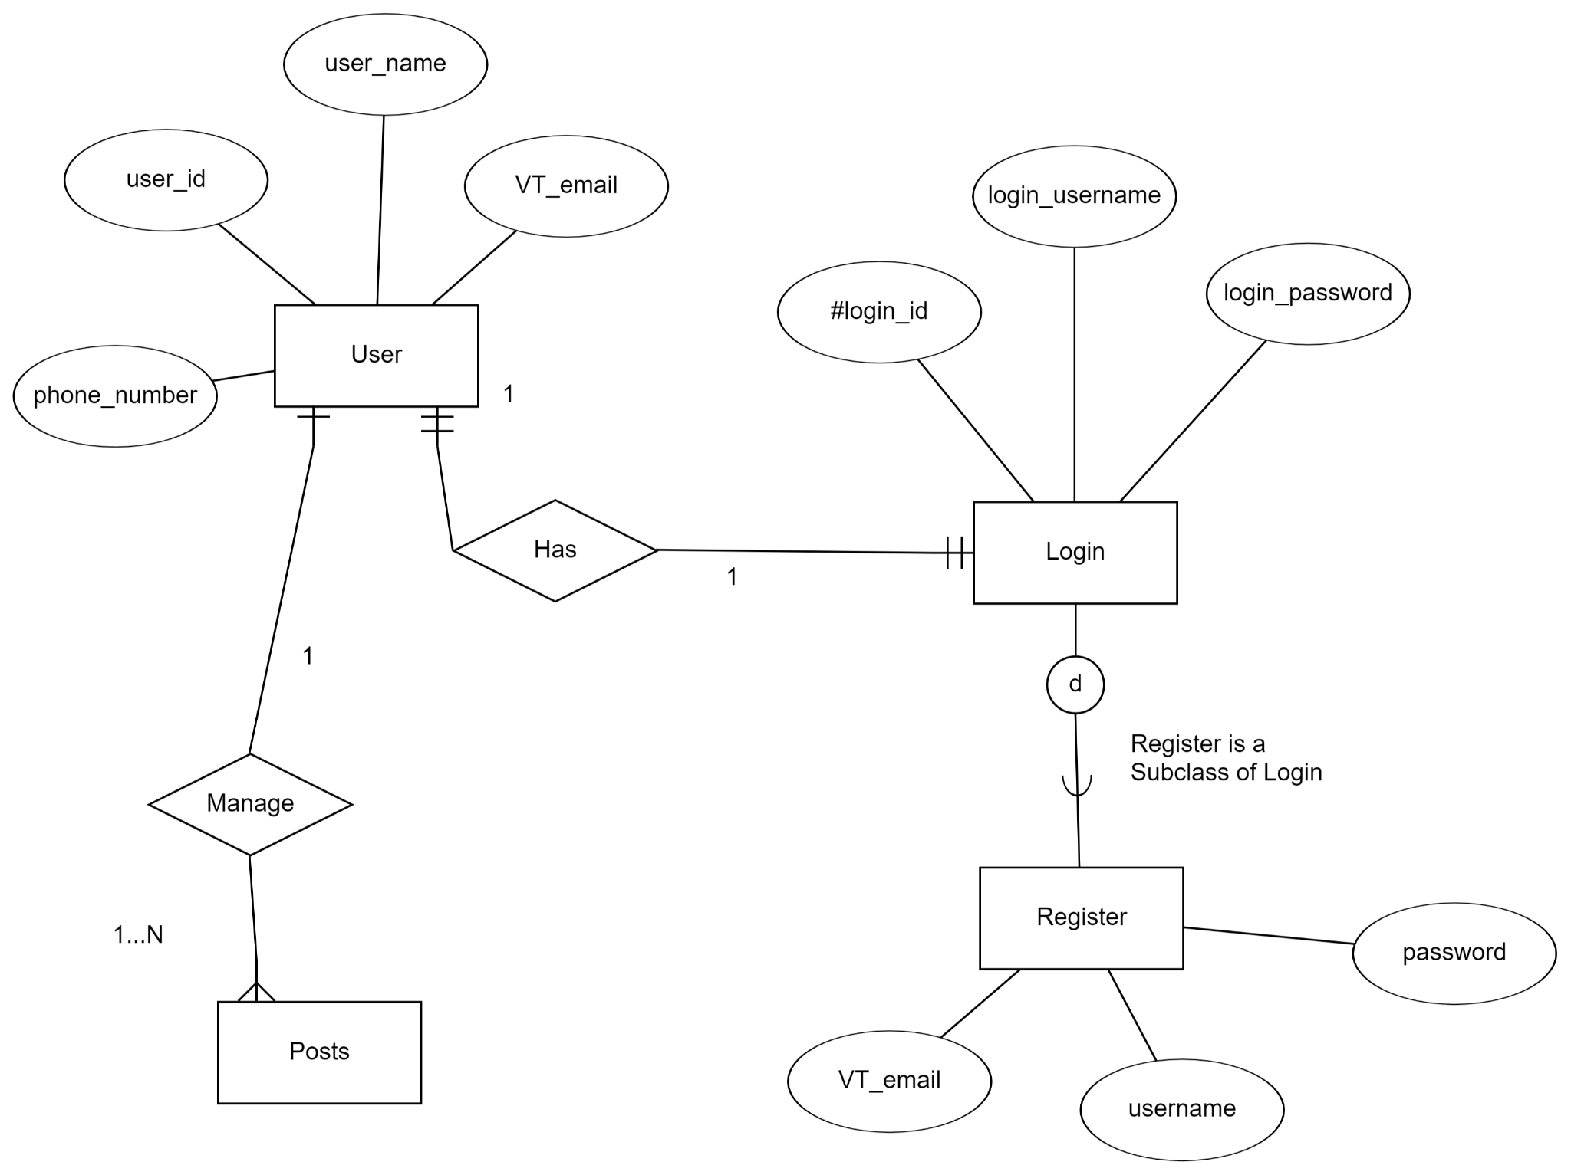

**Table for Login & Registration:**

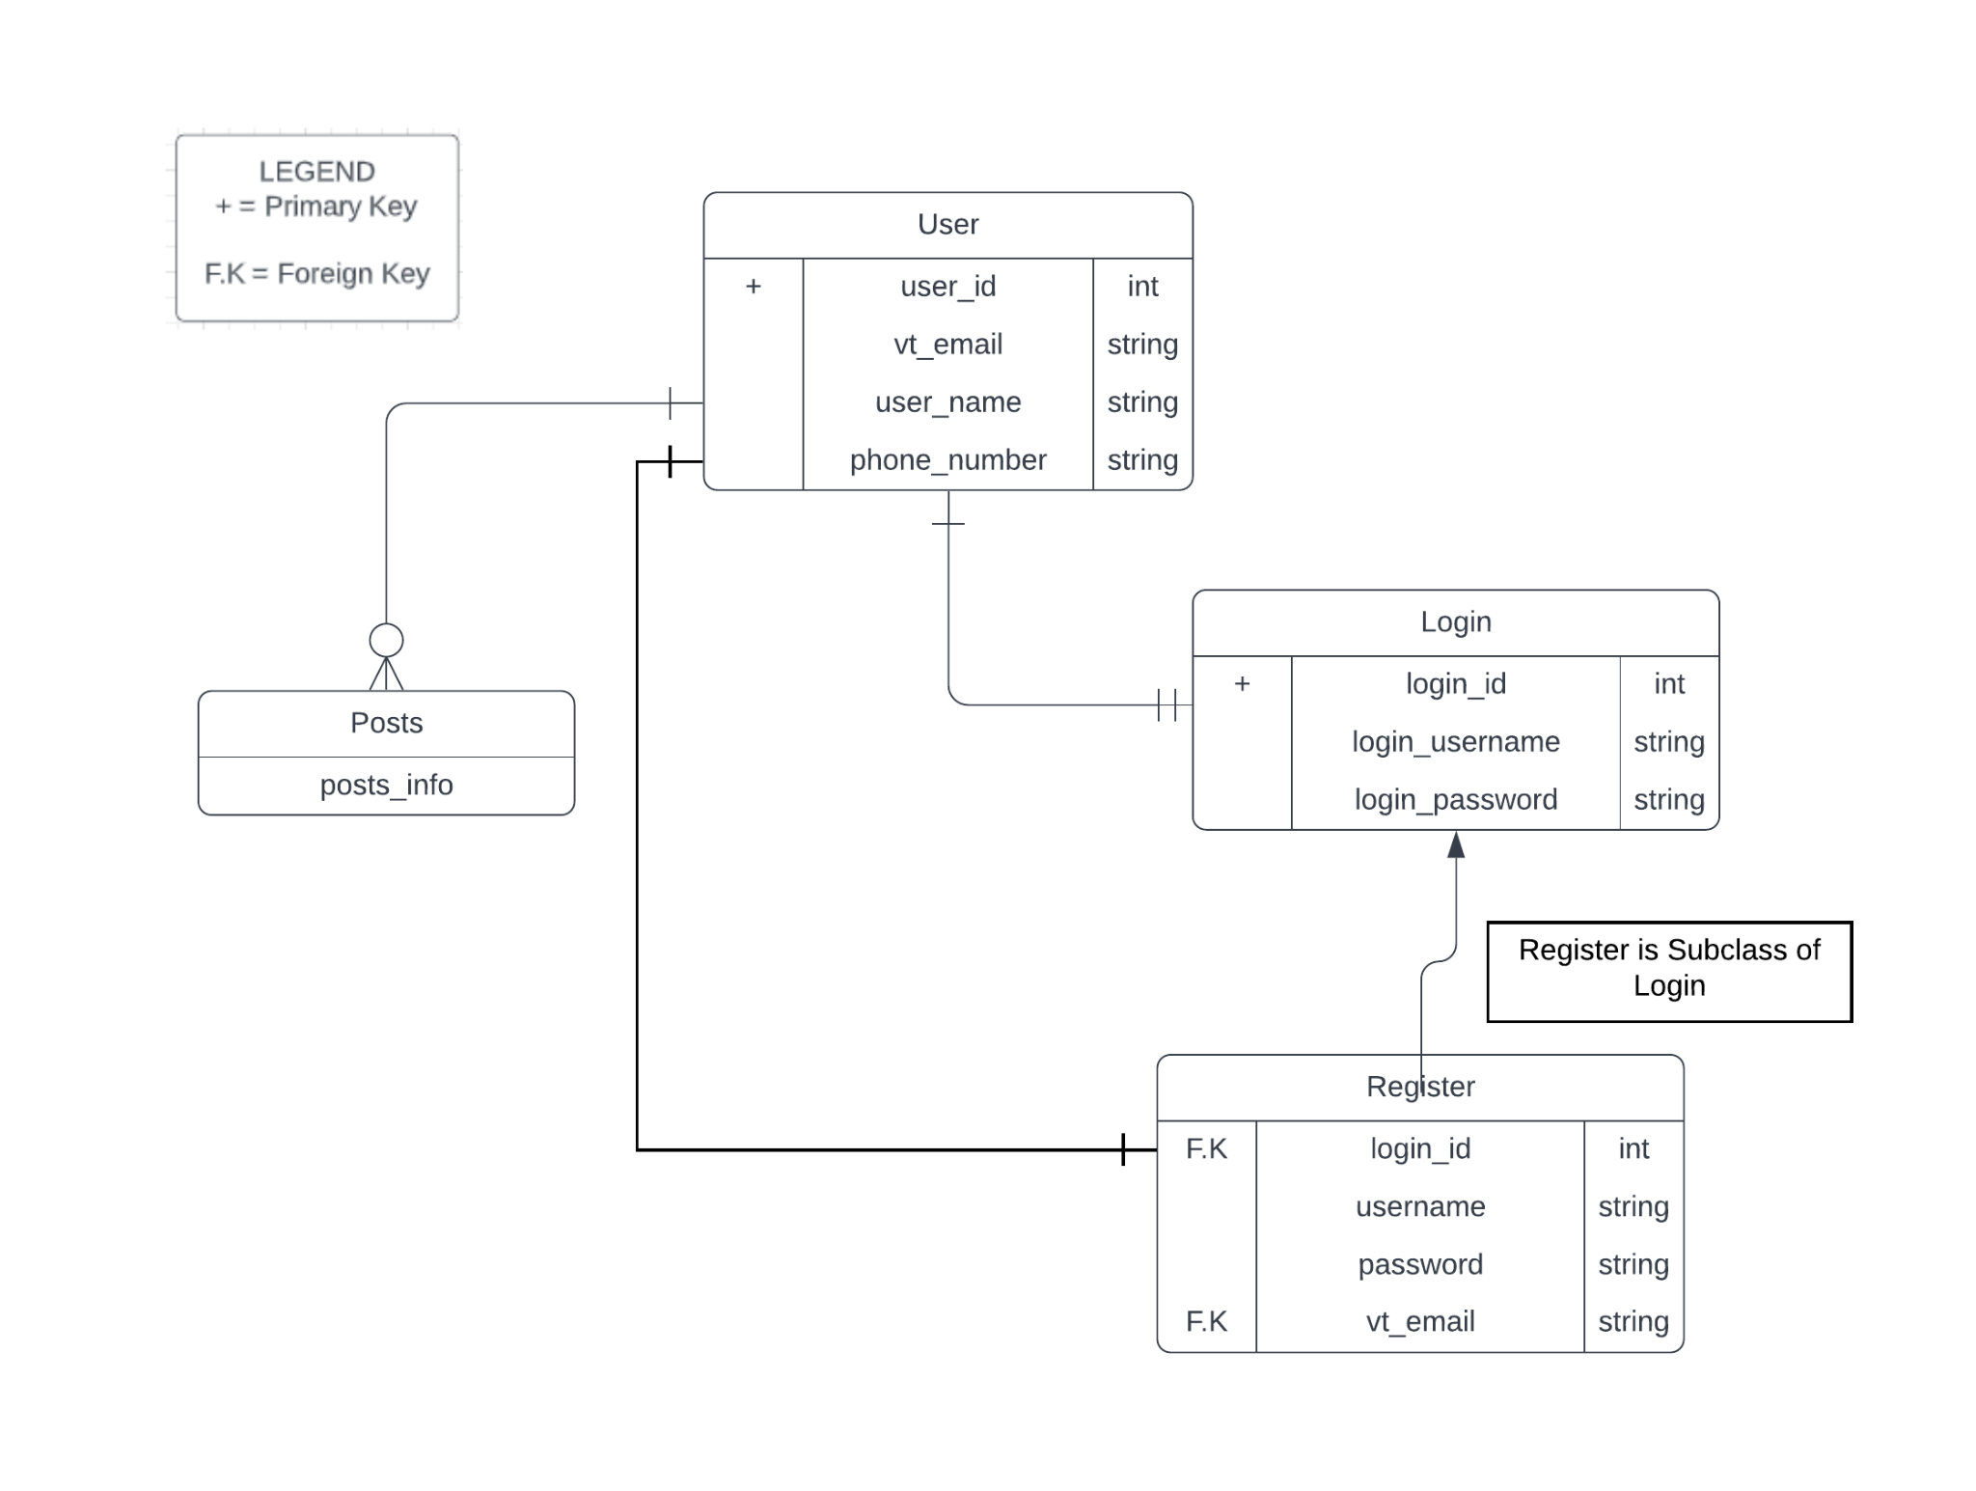

**Class Diagram for Login & Registration:**

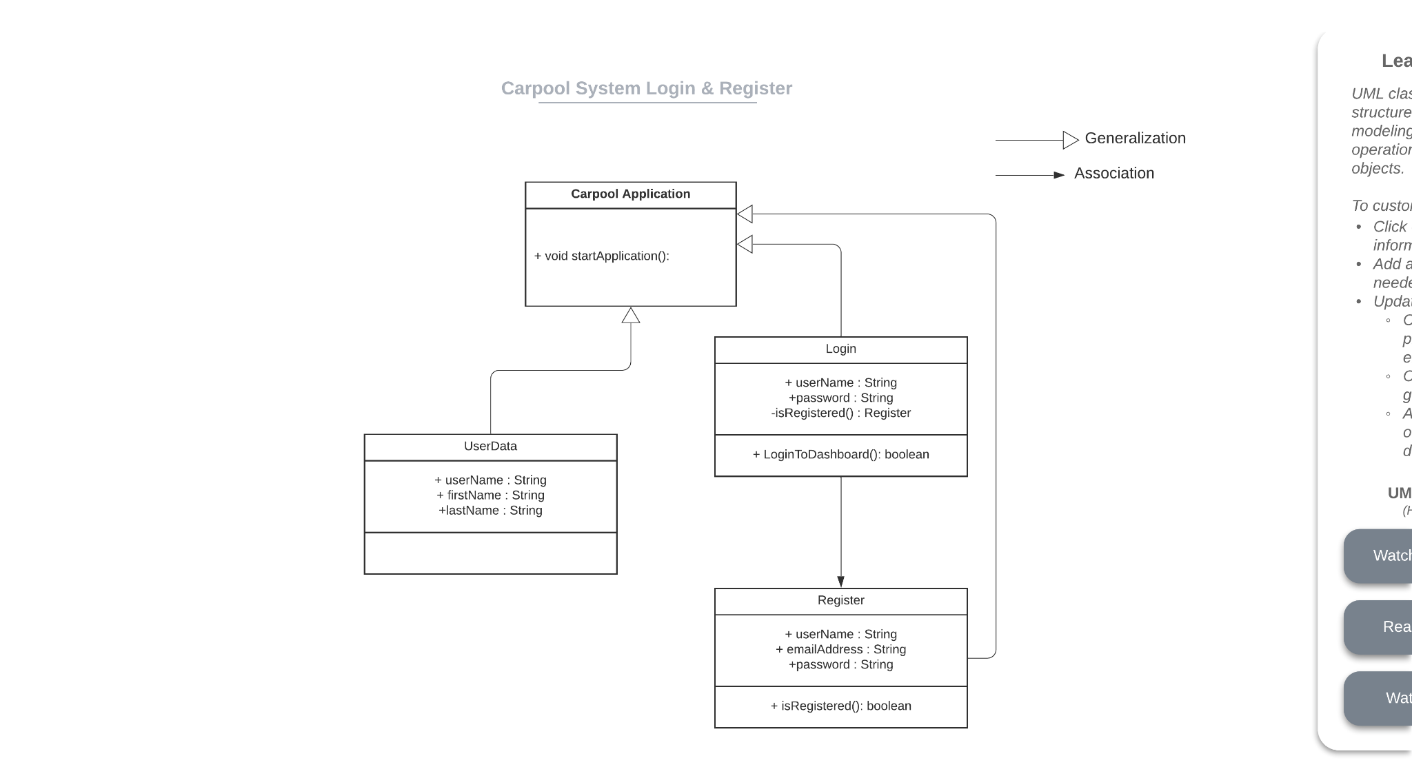

**Create/edit/delete profile & logout**

**Primary Actor:** The User (VT Student/Staff member)

**Entity Relationship (E.R) Diagram for Create/edit/delete profile & Logout:**

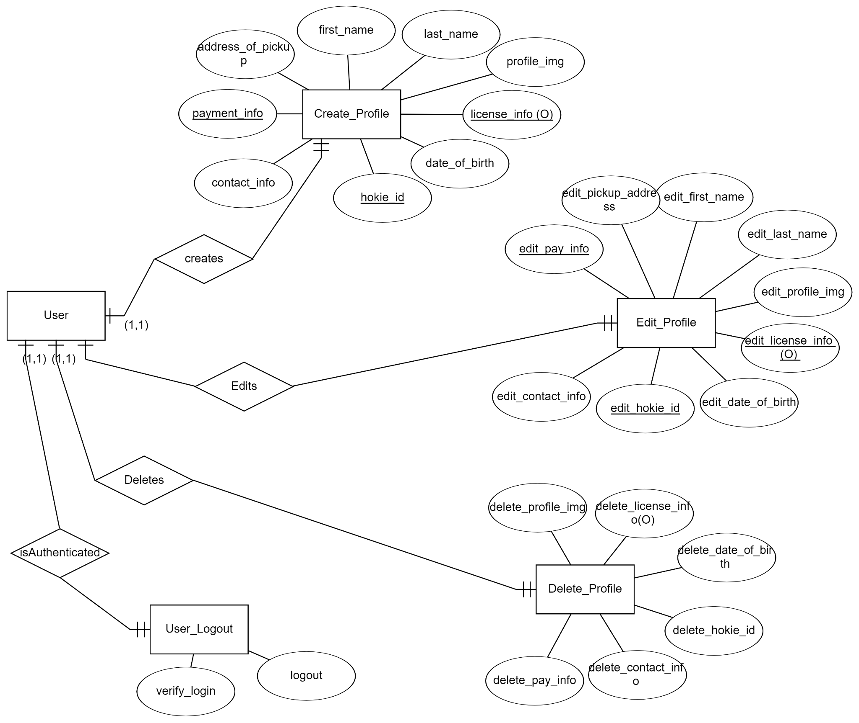

**Table for Create/edit/delete profile & logout**

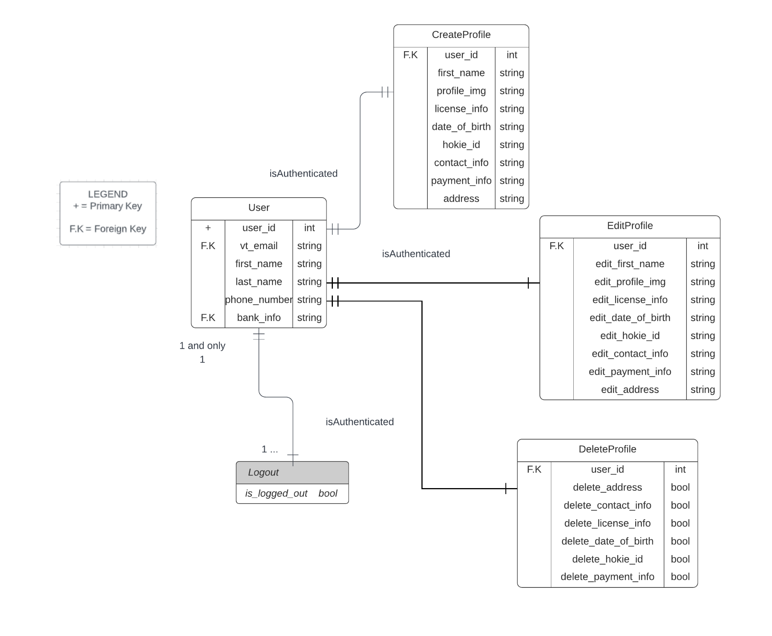

**Class Diagram for Create/Edit/Delete Profile info and Logout:**

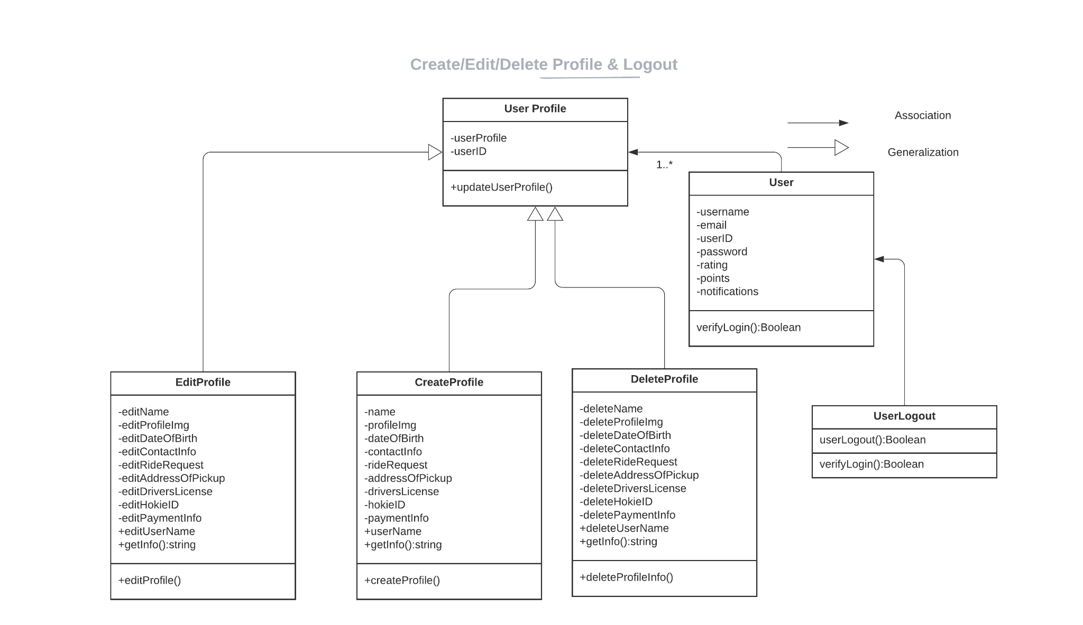

**Ability to Post/Edit/Delete a Trip Listing to the Community:**

**Primary Actor:** The User (VT Student/Staff member)

**ER Diagram for Ability to Post/Edit/Delete a Trip Listing to the community:**

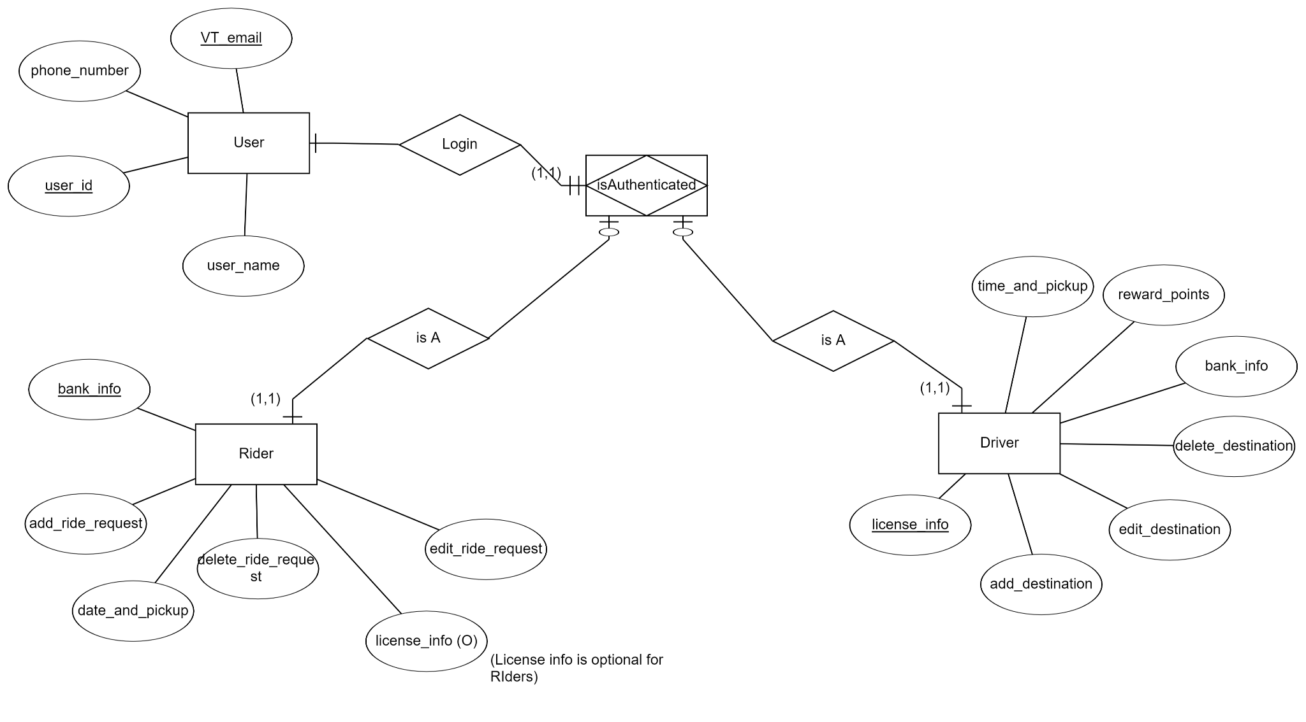

**Table for Ability to Post/Edit/Delete a Trip Listing:**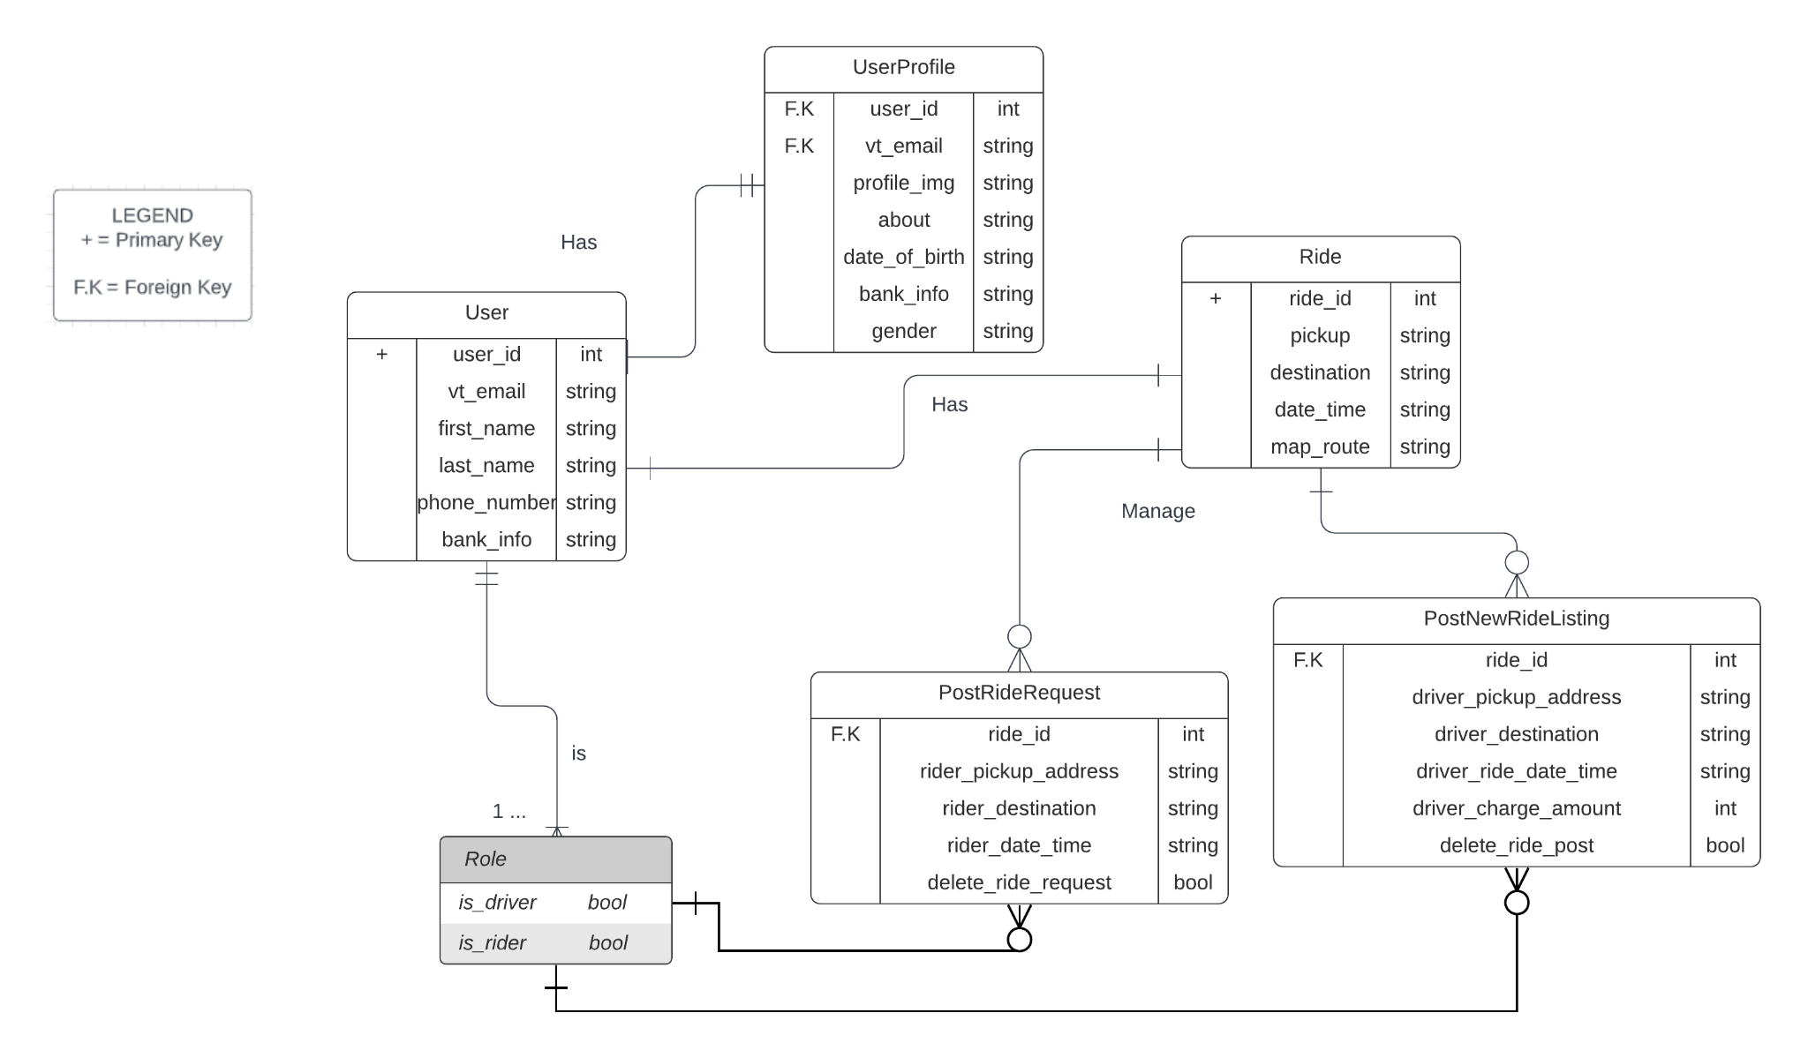

**Class Diagram for Ability to Post/Edit/Delete a Trip Listing:**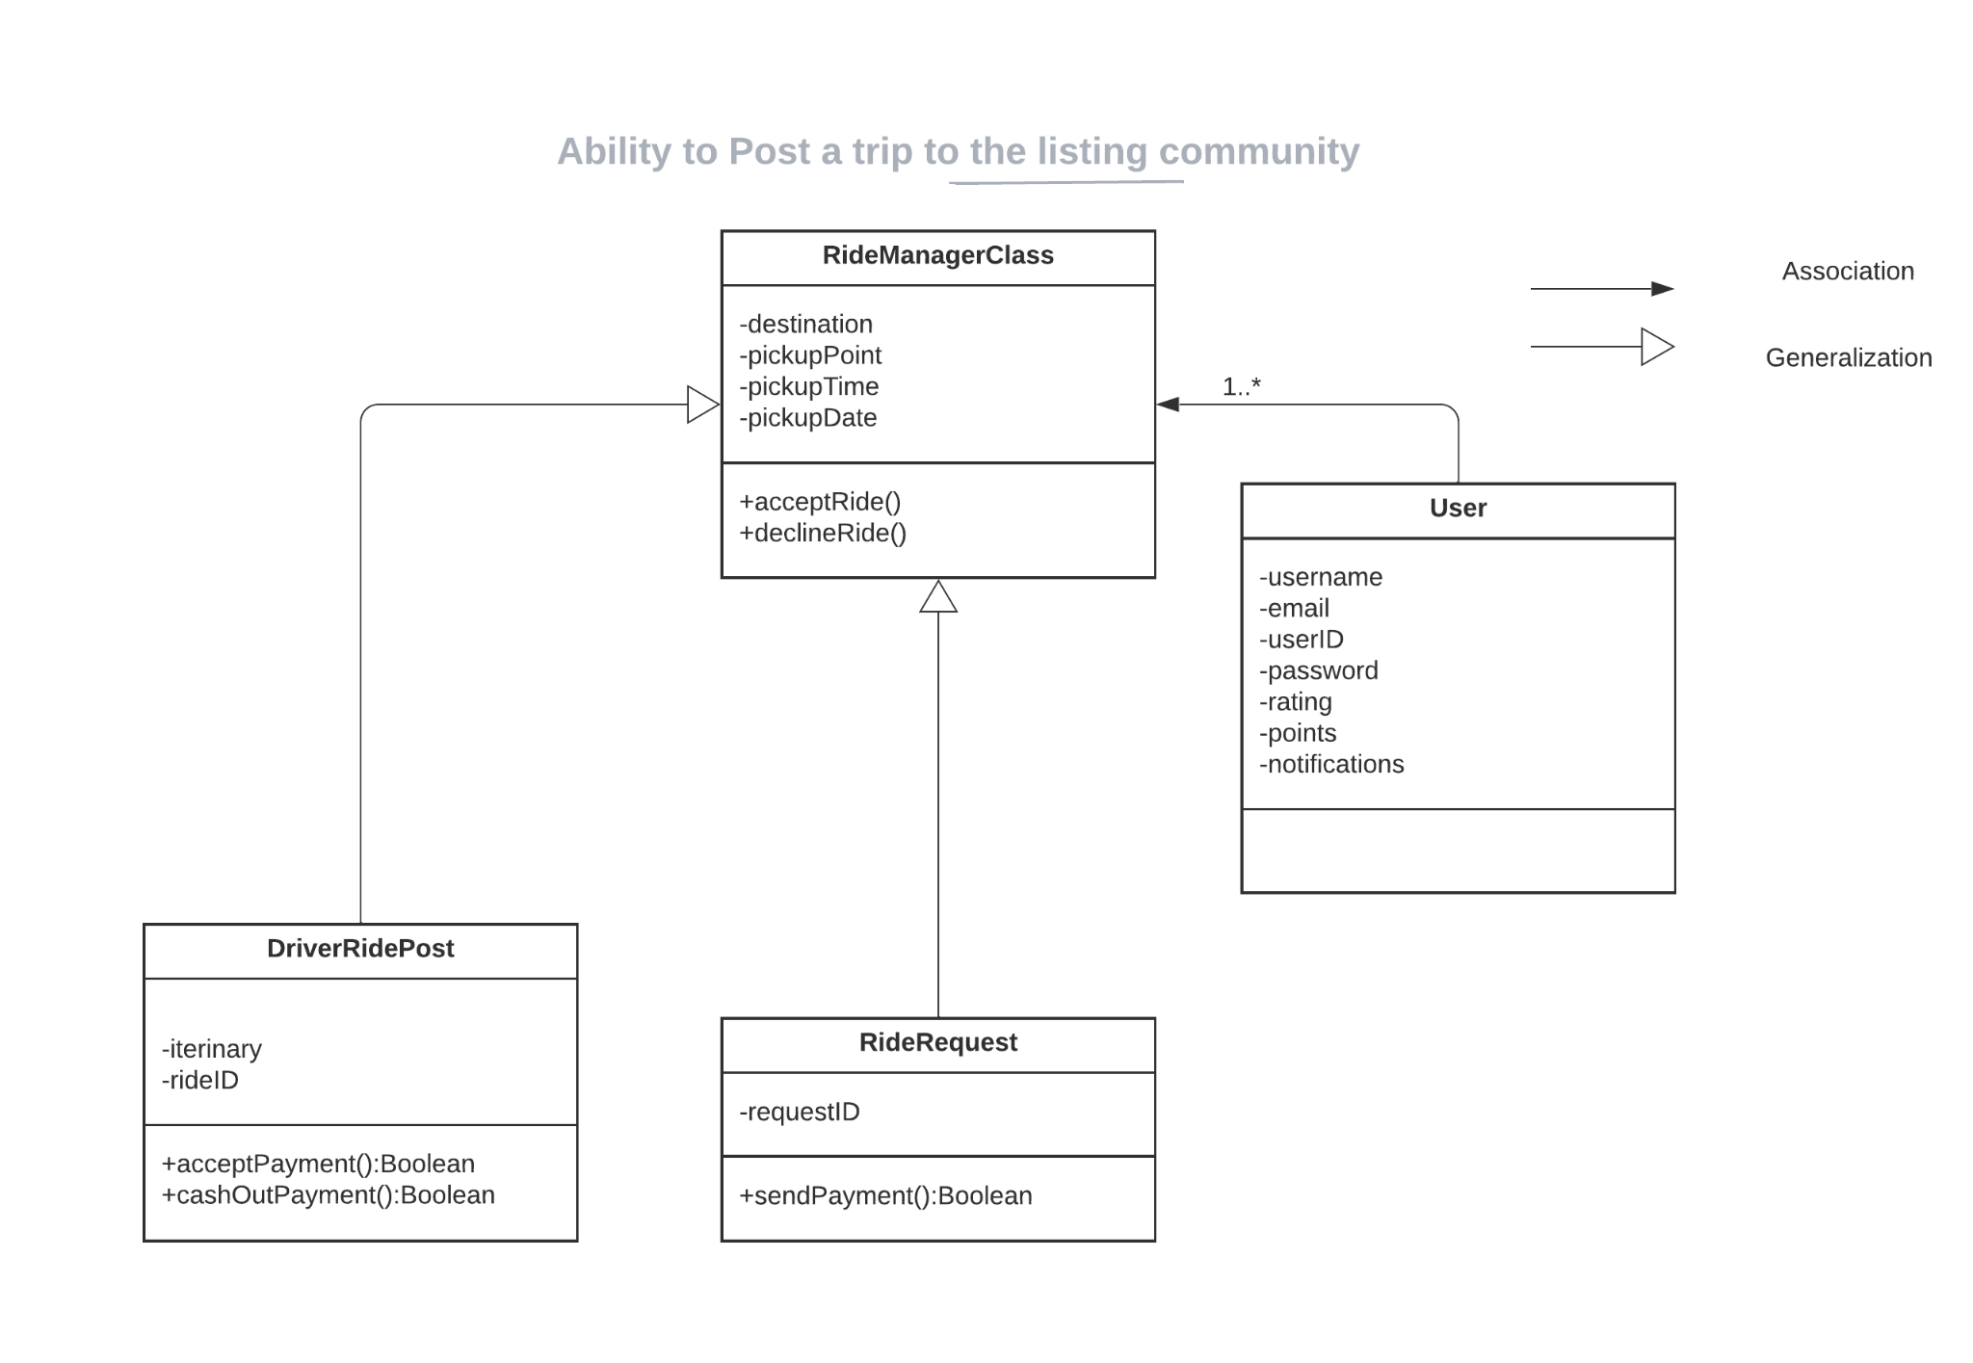

**Sorting Listings**

**Primary Actor:** Driver

**Entity Relationship Diagram:**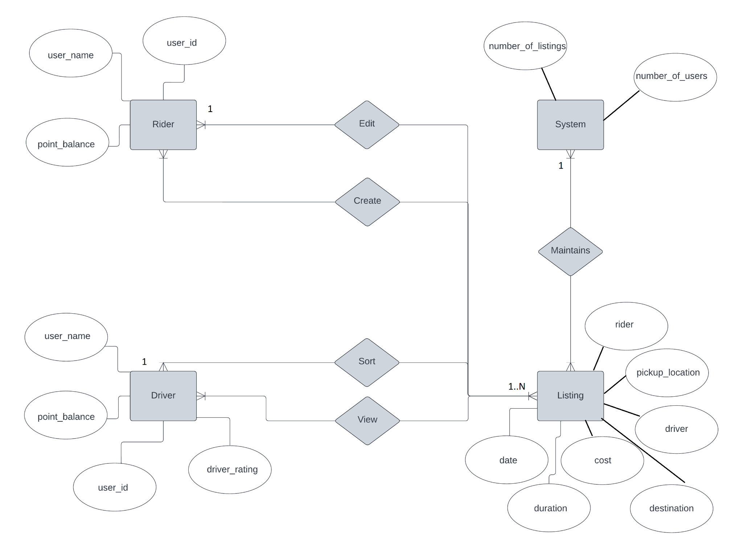

**Table:**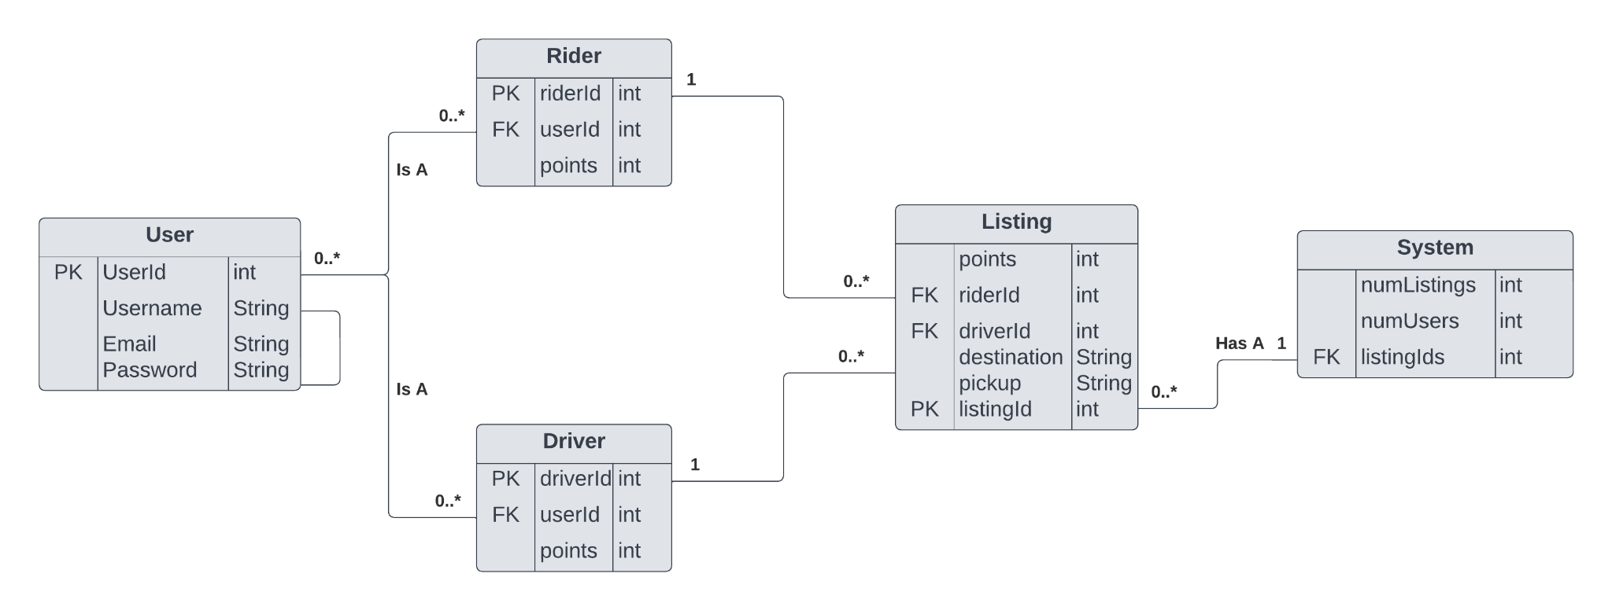

**Class Diagram:** Class diagram shown in Forgot Password

**Transactions**

**Primary Actors:** Rider & Driver

**Entity Relationship Diagram:**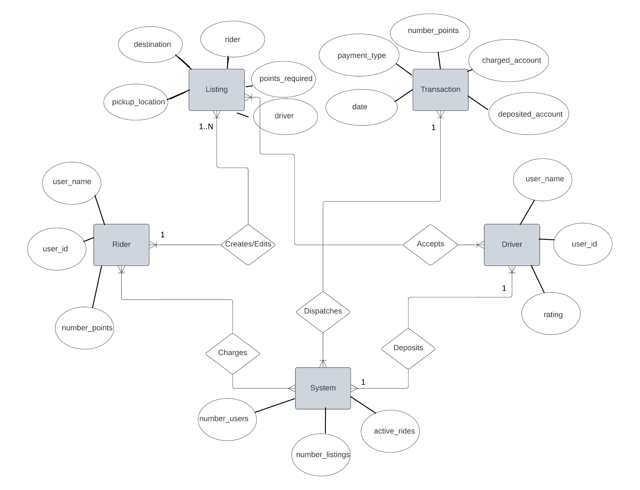

**Table:**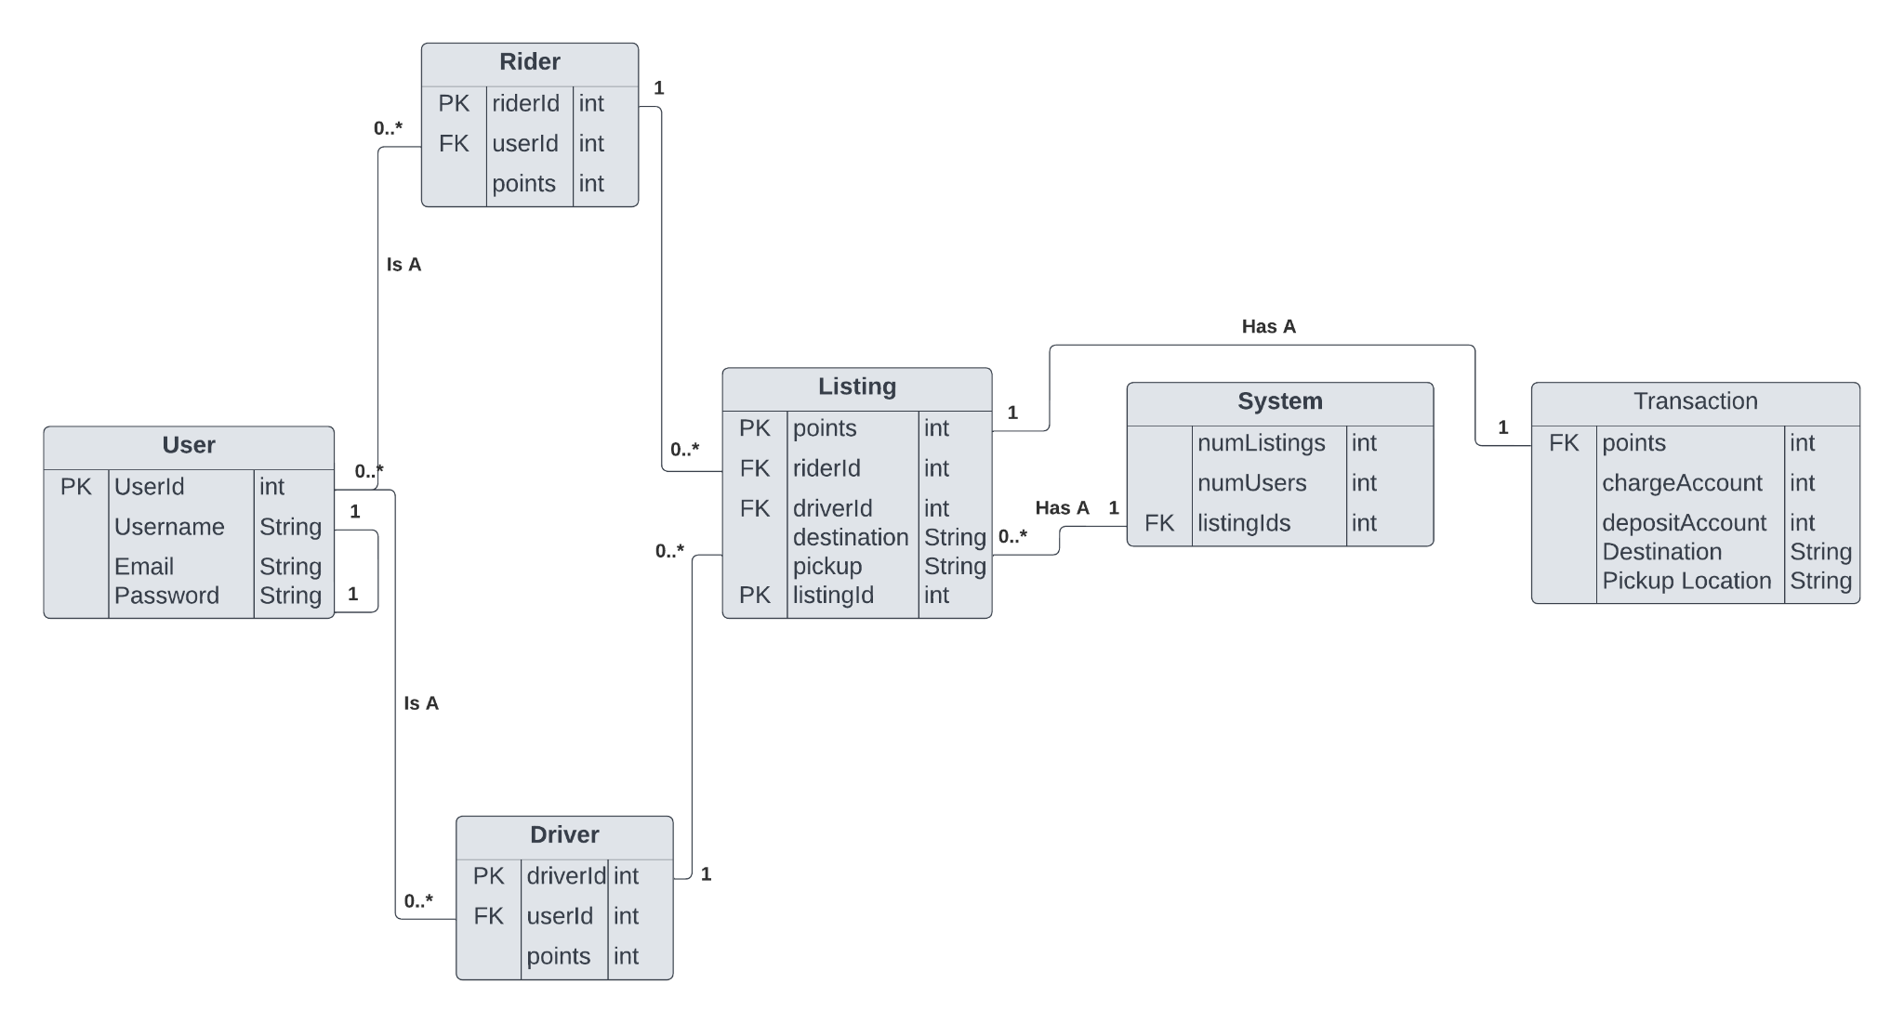

**Class Diagram:** Class diagram shown in Forgot Password

**Forgot Password**

**Primary Actor:** Driver & Rider

**Entity Relationship Diagram:**

**Table:**

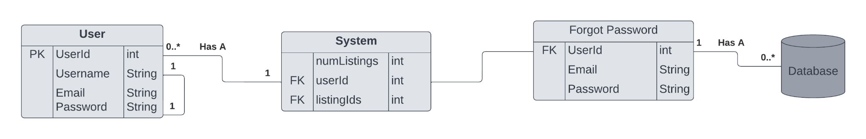

**Class Diagram:**

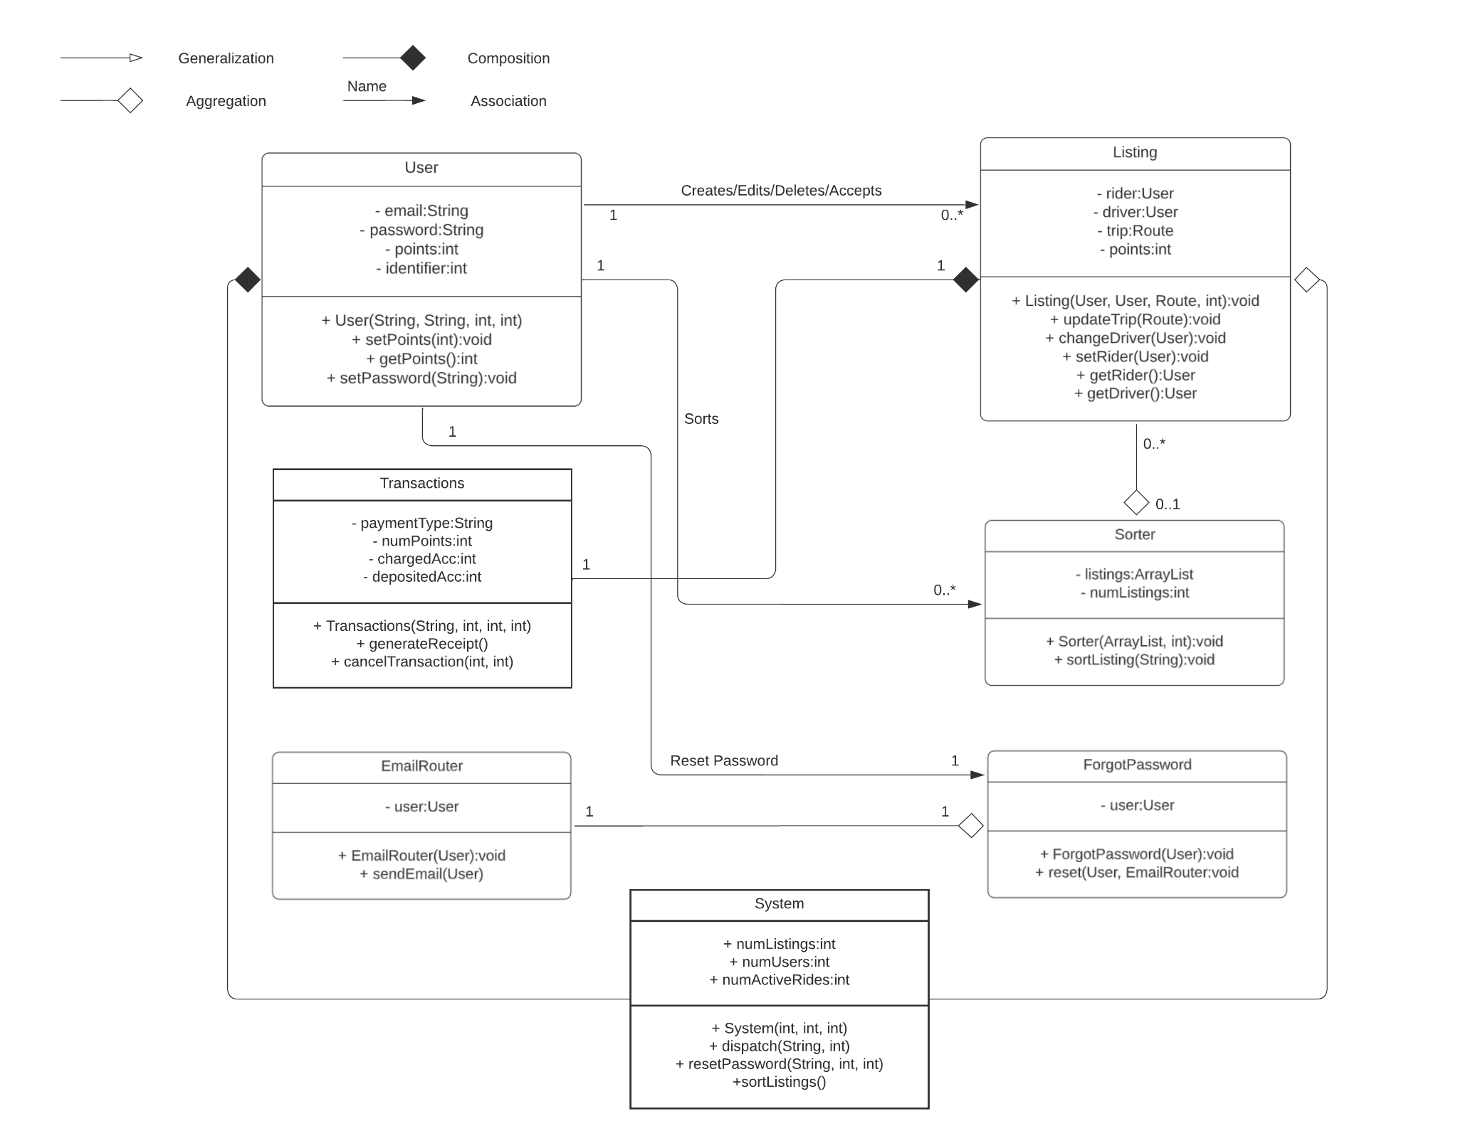

**Email Confirmation**

**Primary Actor:** Drivers & Riders

**Entity Relationship Diagram:**

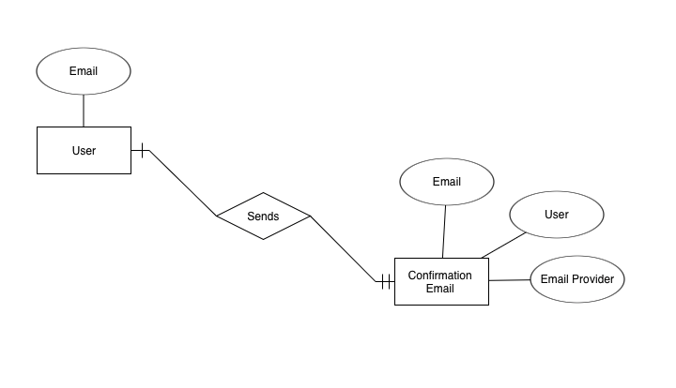

**Class Diagram:** Class diagram shown in Forgot Password

**Table:**

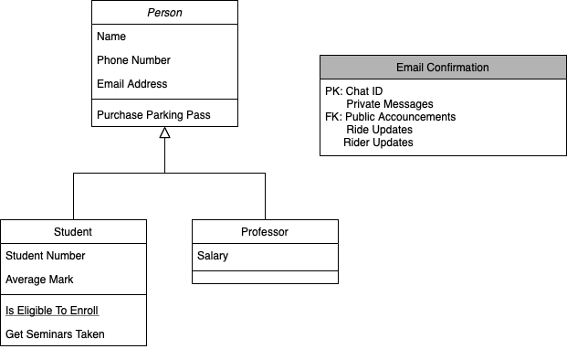

**Trip Duration Estimate**

**Primary Actor:** Rider

**ER (Entity Relationship) Diagram for Trip Duration Functionality:**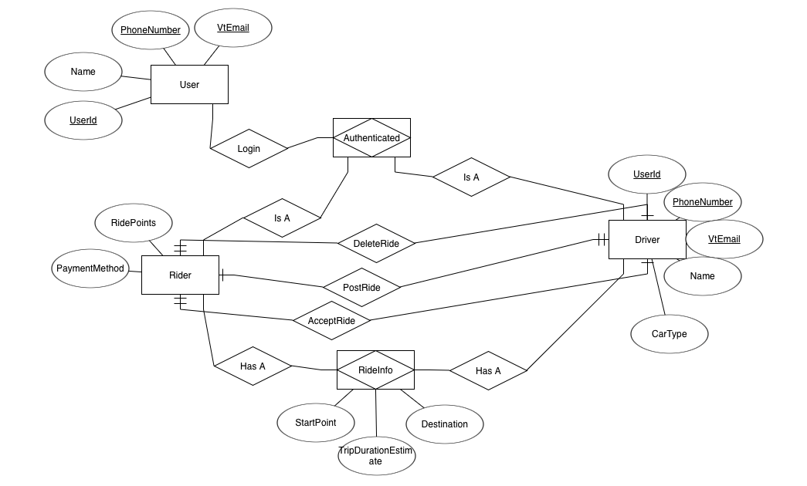

**Table for Finding Trip Duration:**

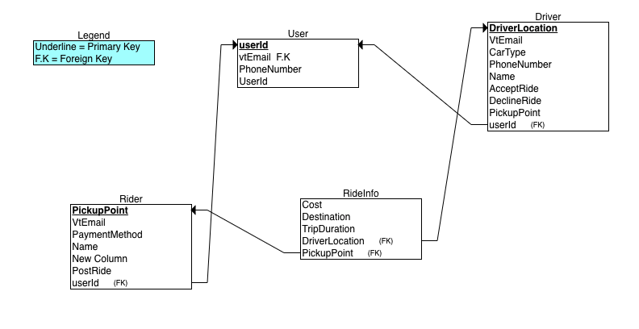**Class Diagram:**

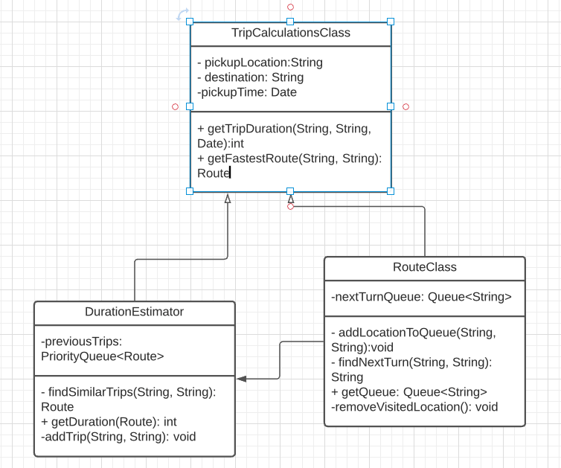

**Route Planning**

**Primary Actor:** Driver

**ER (Entity Relationship) Diagram for Route Planning Functionality:**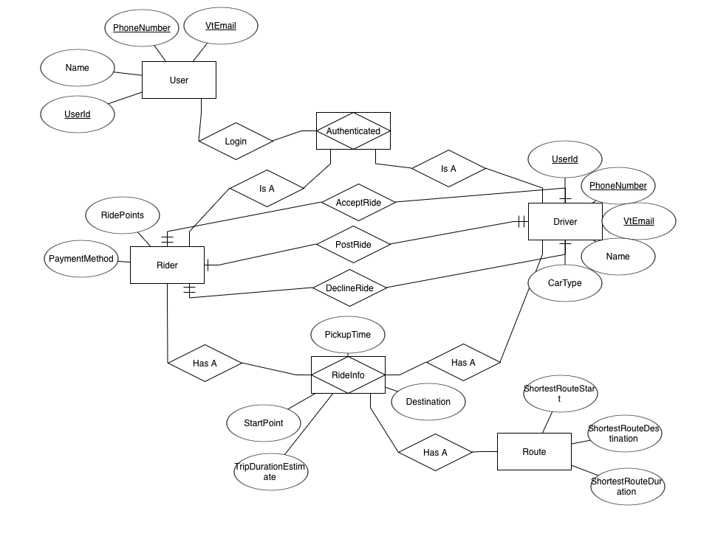

**Table for Route Planning:**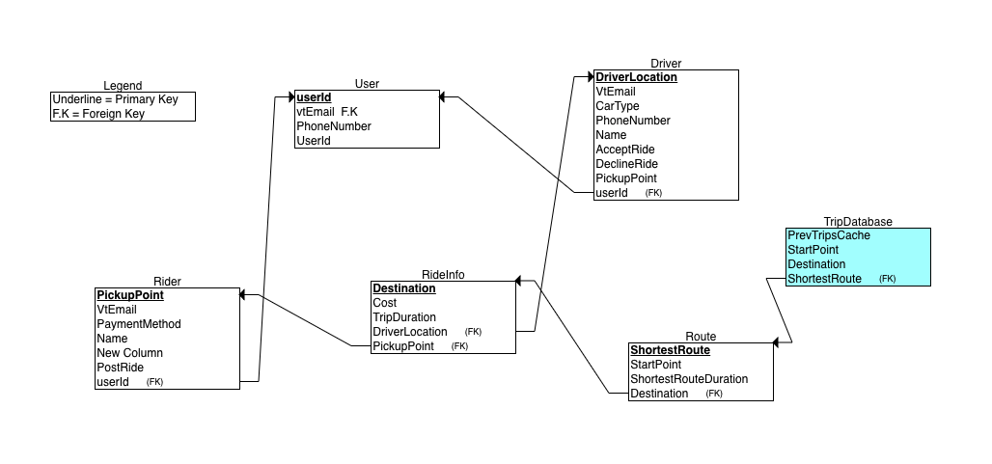

**Class Diagram:**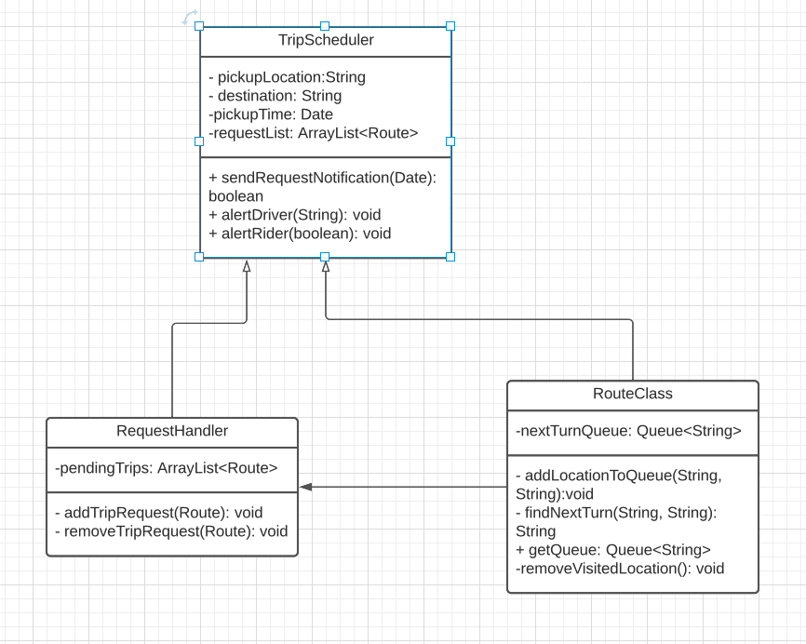

**Pickup Scheduling**

**Primary Actor:** Rider

**ER (Entity Relationship) Diagram for Pickup Scheduling Functionality:**

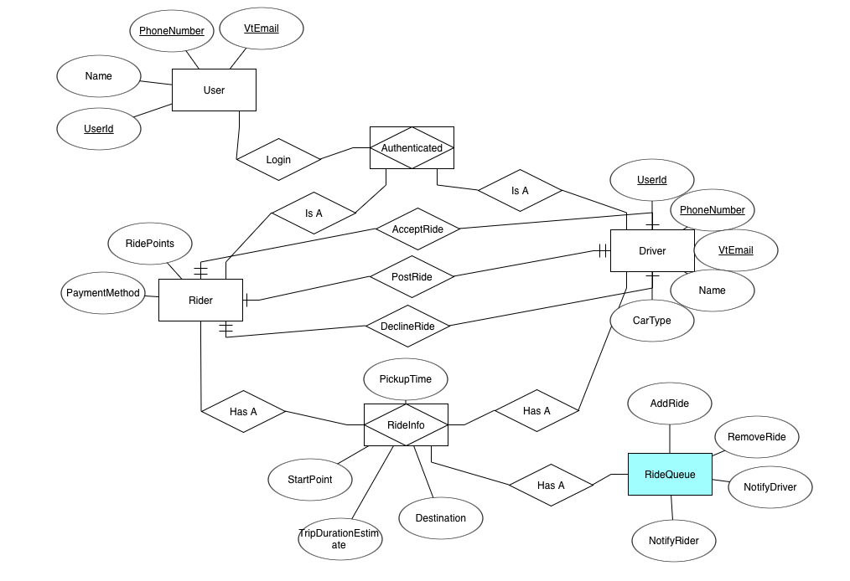

**Table for Trip Scheduling:**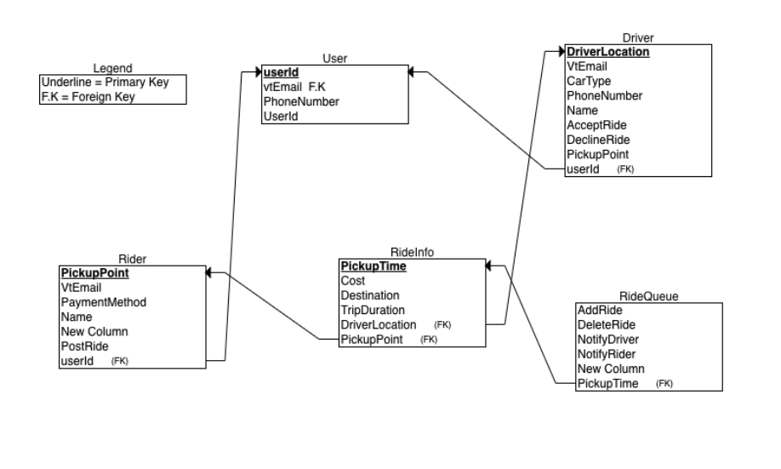

**Class Diagram:**

## **Trip Group Messaging**

**Primary Actor:** Driver

**Entity Relationship Diagram:**

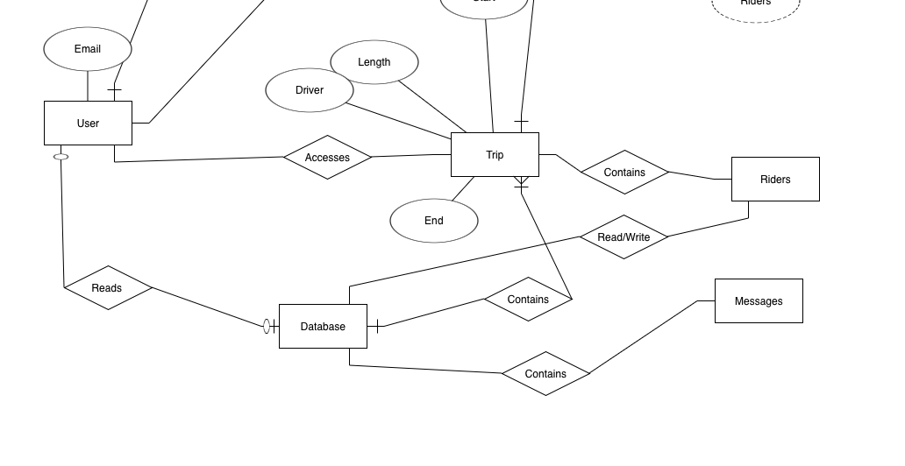

**Class Diagram:**

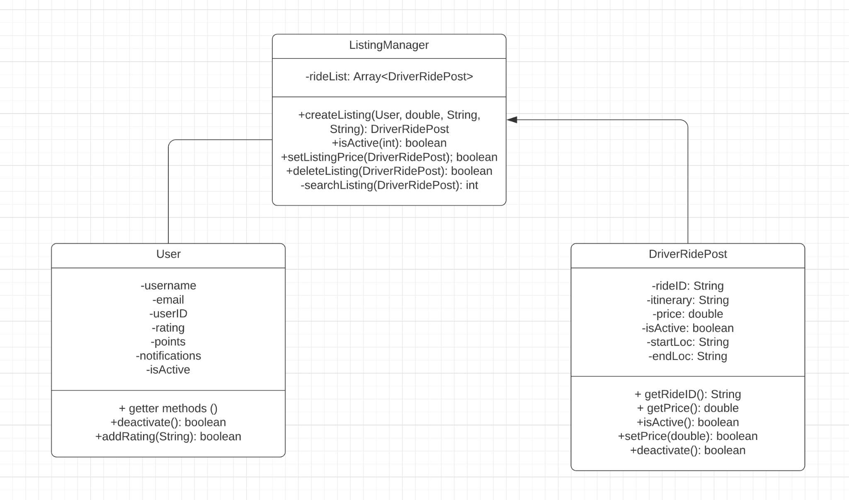

**Table:**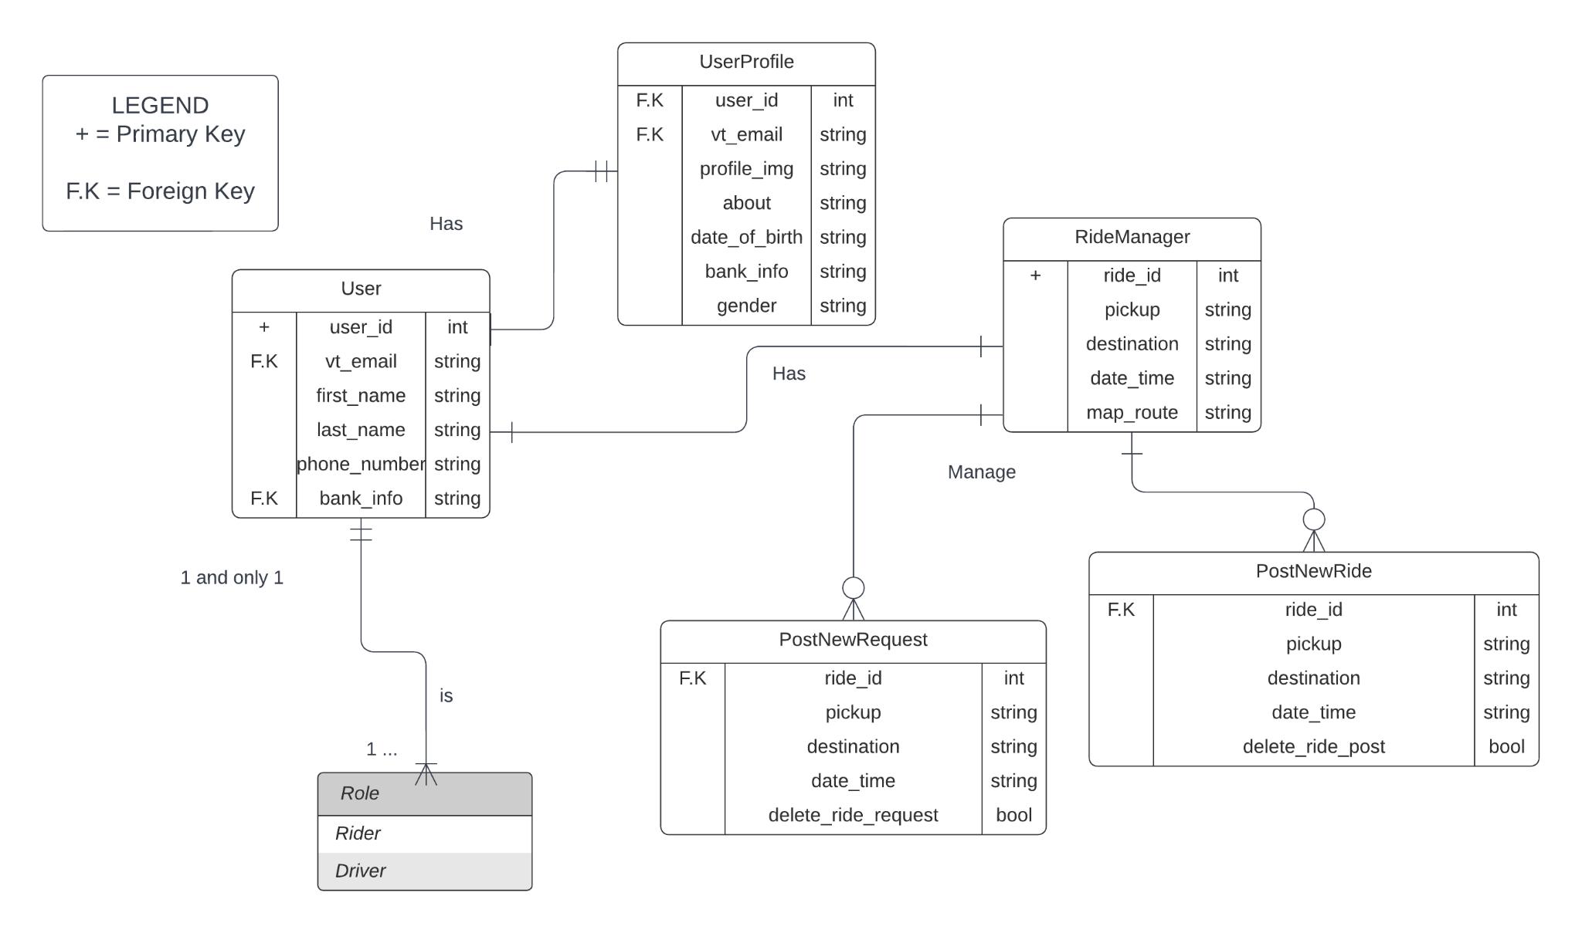

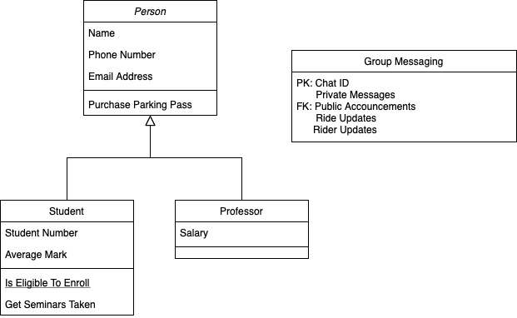

## **Search/Filter Listings**

**Primary Actor:** Rider

**Entity Relation Diagram:**

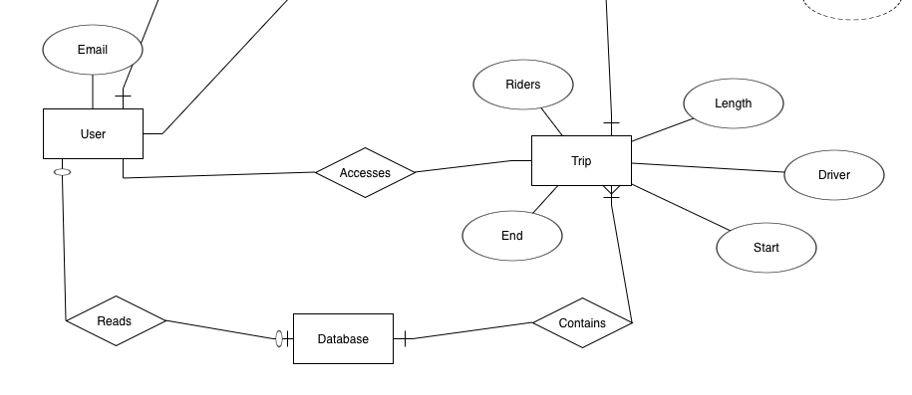

**Class Diagram:**

**Table:**

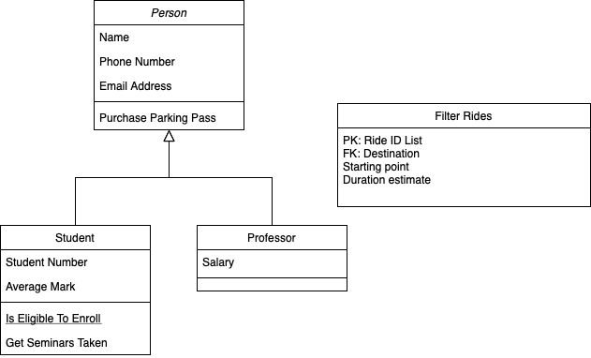

## 

## **Share Ride**

**Entity Relation Diagram:**

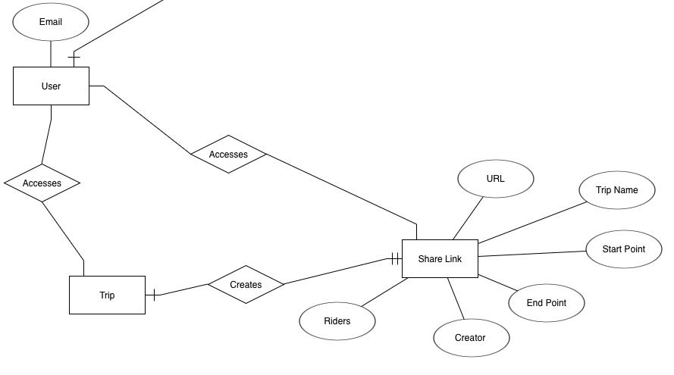

**Class Diagram:**

**Table:**

## 

## **Listing Notifications**

**Primary Actors:** Riders & Drivers

**Class Diagram:**

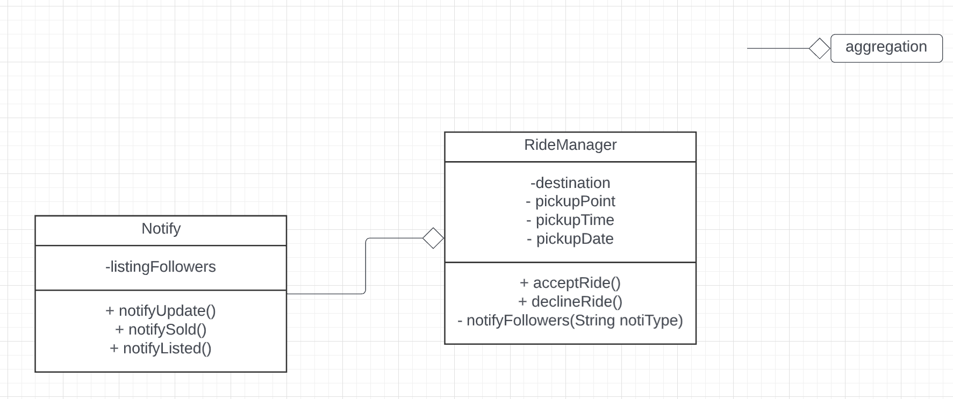

**ER Diagram:**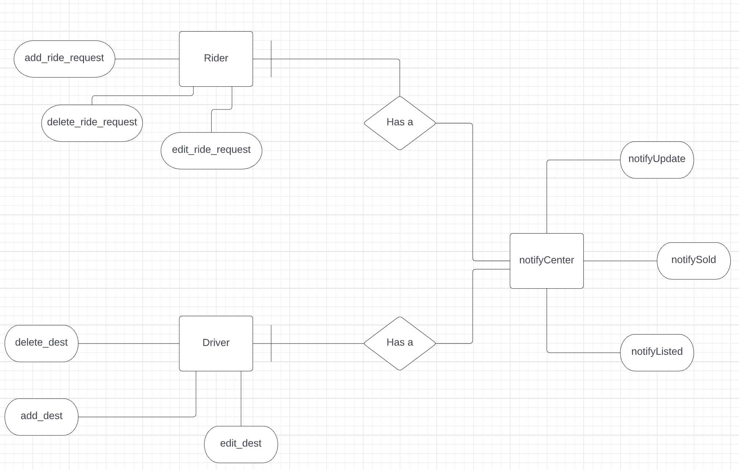

**Table:**

**Maps routing**

**Primary Actor:** The Driver (VT Student/Staff member)

**ER (Entity Relationship) Diagram for Maps Routing Functionality:**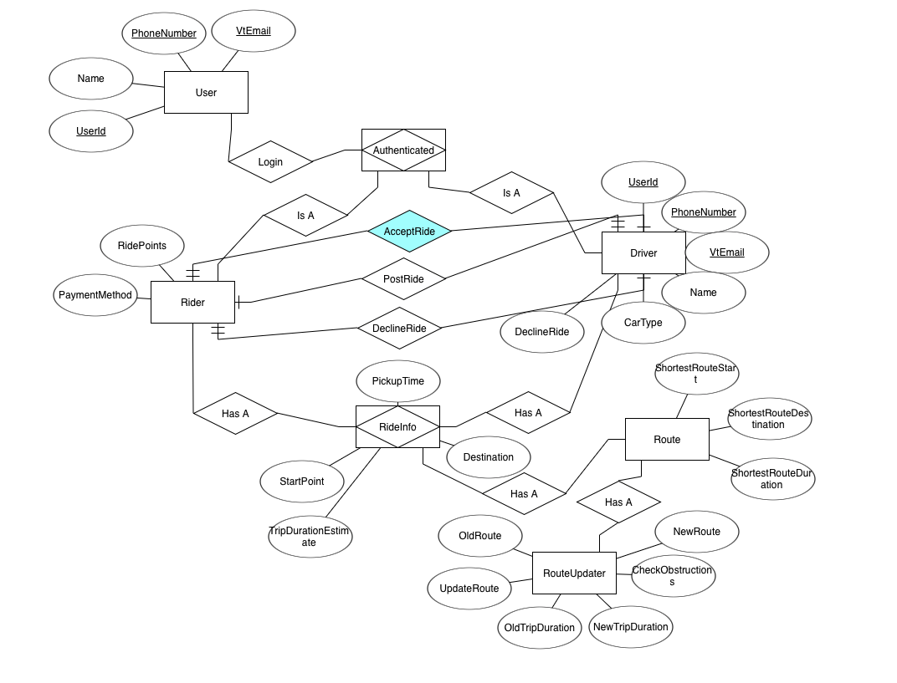

**Table for Map Routing:**

**Class Diagram:**

